Predicting Breast Cancer Diagnosis

##### Authors: Matthew Timmerman, Elizabeth Nieto, Dayana Giunta, Ishita Mehta, Wilson Wu

## Executive Summary

Current screening procedures such as biopsies of tumors can be invasive, expensive, and time-consuming. Instead, the images of the tumors with proper measurements can be used to screen for breast cancer, in conjunction with traditional methods. The data *Breast Cancer Wisconsin (Diagnostic)* was retrieved from Kaggle. Using a breast mass image 10 features of each cell nucleus within the image were collected: radius, texture, perimeter, area, smoothness, compactness, concavity, concave points, symmetry and fractal dimension. From these features the mean, standard error and the worst score of each feature were collected for the image and made up the features of the data set. For each of the original 10 features 3 features were created. There were 685 images and therefore 685 data points with 30 features describing the cell nuclei, one ID feature and one Diagnosis feature. The research goal of this project was to understand if these collected features of a cell nuclei from a breast mass image could be used to accurately classify a breast mass as malignant or benign.

The methods used to analyze the dataset are a combination of multivariate continuous and discrete models, along with cluster analysis techniques. To understand the relationship between the variables and the desired Diagnosis variable, we started with Linear Regression. Since there are often unprecedented cases when it comes to cancer, we decided to not remove any outliers and instead employ regularization techniques such as Ridge and Lasso Regression which provide a way to reduce the variance error introduced by the outliers. Furthermore, the chosen dataset consists of variables that are highly related to each other (such as nuclei radius and area). We used methods that would group redundant variables together such as Principal Component Analysis and Canonical Correlation Analysis which provide a deeper insight into the relationships between the potential variable groupings. Finally, since the goal of the research is to predict where the certain mass is either benign or malignant, we used Logistic Regression and Linear Discriminant Analysis to do the prediction and analyze the performance of our models.

The three models derived from Logistic, Ridge/Lasso, and LDA all yielded significant in predicting capabilities. These three models, with our given 10 main measurement variables, can be used going forward by both doctors and researchers in the breast cancer field to more confidently diagnose a breast mass as malignant or benign from an image. Grouped features established using PCA, Shape, Spread and Symmetry, and those showing a relationship with CCA,  Radius, Perimeter, and Compactness, can be used to guide researchers during forthcoming data collection and help doctors make diagnosis based on shape spread and symmetry which were found to be more important for distinguishing between malignant and benign breast tissue. While we were able to derive significant results, the data presented limitations with relations to the size and diagnosis distribution.

The data was limited in the following ways. The original dataset has more samples of benign cases than malignant cases, which could potentially mean that our chosen prediction model is biased towards benign cases. An implication of a biased model would mean a higher chance of predicting false negatives. Although this risk can be mitigated by using the same model multiple times on the same image. A better solution would be using a higher sample size to train the prediction model. By having a better balance between the provided benign and malignant cases, we can build a more specific prediction model. Future work could also include using the more significant variable groupings to improve the image collection and pre-processing. Even though this research focused on the physical characteristics of the mass, there is abundant research to indicate that the demographics of the patient also plays a role into the cancer treatment plan required. Therefore, by including demographics with the mass characteristics, we can build a better prediction model that reflects the sociological realities along with molecular level analysis.

## Abstract

The determination of what type of tumor is one of the first steps that doctors applied after detecting it. For this examination, one sample is taken from the cells and is analyzed through a biopsy procedure. This paper studies the detection of the type of tumor following the measurements of the features of the breast mass cell nuclei. Different methods were applied, such as linear regression, ridge and lasso regression, logistic regression, linear discriminant analysis, principal component analysis and canonical correlation analysis. The results obtained show the type of breast cancer can be predicted by a coefficient of a measurement from the image of the cell nuclei represented in our data.

## Introduction

The data *Breast Cancer Wisconsin (Diagnostic)* was retrieved from Kaggle. Using the image 10 features of each cell nucleus within the image were collected: radius, texture, perimeter, area, smoothness, compactness, concavity, concave points, symmetry and fractal dimension. From these features the mean, standard error and the worst score of each feature were collected for the image and made up the data set. For each of the original 10 features 3 features were created. There were 685 images and therefore 685 data points with 30 features describing the cell nuclei and one ID feature and one Diagnosis feature. The focus of this project was to understand if features of a cell nuclei from a breast mass image can be used to accurately classify a breast mass as malignant or benign.

## Literature Review

It is no secret that breast cancer and breast cancer awareness is talked about and advertised everywhere today. What isn’t talked about however, is the fact that breast cancer rates in America are rising among certain demographics. According to the CA : A Cancer Journal for Clinicians, “breast cancer incidence rates increased among Asian/Pacific Islander (1.7% per year), non‐Hispanic black (NHB) (0.4% per year), and Hispanic (0.3% per year) women” from 2005 to 2014 and “approximately 252,710 new cases of invasive breast cancer and 40,610 breast cancer deaths are expected to occur among US women in 2017”. Among different breast cancers, there is a different in molecular shape depending on the exact type of breast cancer and tumor. The Breast Cancer Research Journal claims that “In breast cancer, gene expression analyses have defined five tumor subtypes (luminal A, luminal B, HER2-enriched, basal-like and claudin-low), each of which has unique biologic and prognostic features”. All five of these molecular subtypes of breast cancer tumors can be identified and then specific treatment can be given to target that individual subtype. In addition to molecular subtyping, a link has been found between the vascularity in breast cancer tumors and certain factors in the bone marrow of a patient. There is a “significant positive association between angiogenesis at the primary tumor site and micro metastasis” in the bone marrow of a patient, as outlined by the Journal of the National Cancer Institute.

## Methods

## To address the following research question of whether features of the breast mass cell nuclei can be used to predict whether the mass is benign or malignant, we employed the following methods. Studying the breast cancer prediction is a rigorous job. the risk of having an erroneous model can cost a person's life. For this reason, it is very important to have the most accurate formula. Initially, to explore the relationship between the features and the response variable *Diagnosis*, linear regression and logistic regression were used, dividing the data by training (70%) and test (30%). Even though it is recommended to use logistic regression model when having binary variable, linear regression model helps us to explore the variables giving us interesting results. The best results were undoubtedly the logistic regression, giving us the formula to predict using whether the mass is benign or malignant using 13 different measures.

Since we noticed outliers in the dataset that could not be removed due to the highly sensitive nature of the medical domain, we explored regularization methods to help address the error in the regression models. We split the data into 70% training and 30% test and apply data into Tikhonov regularization (Ridge regression) and least absolute shrinkage and selection operator (LASSO) to evaluate the Breast Cancer Wisconsin. The Ridge is a regression method that performs L2 regularization. The Lasso is a regression method that performs L1 regularization and variable selection when the data has a huge number of features. After finding the best lambda.min and lambda.1se by using 10-fold cross-validation to fit the model, we apply 30% test into each Ridge and Lasso model to predict the mass and find out the best accuracy model.

The dataset has a smaller sample size than usually recommended for the conventional training and testing split approach for prediction. Therefore, we also used the classification technique Linear Discriminant Analysis (LDA) to predict diagnosis based on all the features of the mass. Due to the small size of the dataset, k-cross validation was used, and the model’s performance was compared with the rest of the models.

Furthermore, the features are also highly multicollinear. To avoid overfitting the dataset, we explored cluster analysis technique Principal Component Analysis (PCA) for dimension reduction. To prep the data for PCA two features were removed. These were the *Diagnosis* feature and the *ID* feature. Kaiser Meyer Olkin (KMO), Bartlett’s Test of Sphericity and Cronbach’s Alpha were used to test the data for Factorability. This was followed by the first PCA model on the data. Using this first model the scree plot was used to derive the number of components using Kaiser Meyer and the knee method. Once the number of components was selected PCA was ran again, this time with a higher cut off method to remove overlapping features among components.

With our 30 measurement values, we decided to look at our 10 mean measurements for a Canonical Correlation Analysis (CCA) as these 10 measurements were the stronger choice to look for correlation over standard error and worst case. These ten measurements were split into two groups, with 4 variables being in the standard measurements group, and 6 variables being in the specialized measurement group as seen in figure 6.1**.** These measurements were originally split by intuition and how the data was grouped originally, and then verified to work through testing. Canonical Correlation dimensions were judged based on their p-value after running a hypothesis test on all 4 dimensions using the Wilk’s Lambda test statistic. Canonical Dimension groupings were then formed using the standardized coefficients of the two groupings, and groupings were labeled with the amount of variability they explained from the data.

## Discussion and Results

### Preliminary Results

###### Linear Regression

For the first linear regression model, all the variables were plugged into the model, getting good R2 and adjusted R2. However, this model was discarded due the multicollinearity (Figures1.1).

A second try was made using the stepwise selection method, where backward and forward selection play an important role. Even though this model improves with respect to the statistical significance, the model still had multicollinearity present. (Figure 1.2)

For the last try using linear regression model, the variables with high multicollinearity were deleted, ending with a total of 14 variables. This model had a satisfactory result in reference to the R2 and adjusted R2 , also this model is statistically significant and there is no multicollinearity (Figure 1.3).

###### Ridge and Lasso

For the Ridge regression result, the plot coefficients with log lambda (Wilson figures.1) shows the result that when we increase Log Lambda more and more, almost all the variables shrink into coefficients close to zero, but never drop off from the model. Next, to find the best lambda for our Ridge Model, the plot misclassification error with log lambda (Wilson figures.2) indicate that when log lambda around -2 which are the vertical dotted line interval, the model has =low misclassification error. One is Lambda.min 0.0677 which is the value that gives a minimum mean error, and the other is Lambda.1se: 0.207 which is the value that gives one standard error of the minimum. Between Lambda.min and Lambda.1se have amount difference. We apply both Lambda.min and Lambda.1se into our model. Both Lambda models keep all the variables and show the same accuracy. After applying this model to the testing set, this mode indicates that prediction accuracy for the mass is 94.73%, Moreover, the false negatives for the prediction 8.49%.

For the Lasso regression result. The plot coefficients with log lambda (Wilson figures.3) shows the result that when we increase Log Lambda more and more, more variables shrink into coefficients to zero. Moreover, we found that when the log lambda is -2, the only concave_points_worst variable still stay significant. To find the best lambda for our Lasso Model, the plot misclassification error with log lambda (Wilson figures.4) indicate that when log lambda around -5.3 which are the vertical dotted line interval, the model has good prediction and acceptable numbers of variables. One is Lambda.min 0.0045 which is the value that gives a minimum mean error, and the other is Lambda.1se: 0.0054 which is the value that gives one standard error of the minimum.

We apply both Lambda.min and Lambda.1se into our model. Lambda.1se indicate less dimension and better accuracy, so we pick Lambda.1se model for our model. Lasso Lambda.1se shrink all variables to 10 significant variables. fractal dimension in se, smoothness in worst, and concave_points in worst have high coefficient values for the models.

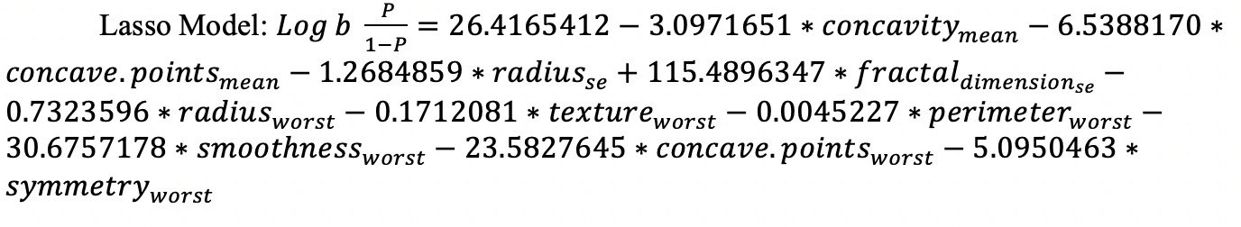

After we apply this model to our testing set, this mode indicates that prediction accuracy for the mass is 97.66%, Moreover, the false negatives for the prediction 0.94%. Finally, we compare Ridge regression and Lasso regression. We maintain that Lasso model for breast cancer has higher prediction accuracy and not overfitting model. Furthermore, Lasso model has much lower false negatives prediction. We think is important for the not predict malignant to benign.

###### Logistic regression

Using the third model, from the linear regression analysis with 13 variables, we applied the logistic regression model. As a result, we end up with statistically significant for almost all variables, giving us the good signal to choose and make our predictions analysis (Figure 3.1).

One advantage of using linear regression model is to be able to use the r2 to ensure the model can be useful or not. On the contrary, in logistic regression this step is difficult to calculate, since the prediction line is not a straight line. McFadden (1973) suggested an alternative for the logistic regression, known as “likelihood ratio index”, comparing a model without any predictor to a model including all predictors. It is defined as one minus the ratio of the log likelihood with intercepts only, and the log likelihood with all predictors. For this model the McFadden score is 0.70 meaning that this model could be a strong predictor in order to answer our research question.

Now, having the coefficients we can explain the assumptions. For example, If the texture_mean increase by one, the logOdds will increase by 0.49. To better understand the log of the odds is the division of the probability of getting breast cancer benign and the probability of getting breast cancer malignant. In other words, the odds will be the exp(coefficient) and the logOdds will be the (odds-1) *100 this result is the percent of increase when the variable increase by 1 unit. Logistic regression showed that not all variables have the same importance to the model, such as symmetry_mean, texture_se, concavity_se and fractal_dimension_se.

Previously the data was divided by training (70%) and test (30%). Now, in order to see if the model works, the probability of the prediction using the test data was calculated using the best model from the logistic regression (13 variables), creating a confusion matrix. Therefore, we end up with a really good results of 101 cases of true positive vs 8 case of false positive and 48 cases of true negative vs 14 cases of false negative (Figure 3.2).

After that, we calculate the error rate that is 0.0994152 that its very satisfactory and subtracting it to 1 we will get the accuracy rate that is almost 90%. Additional to this, we plot a ROC curve, getting a 0.96. As we know, the upper level of the line is, the better is the model (Figure 3.3)

###### Linear Discriminant Analysis

Linear Discriminant Analysis (LDA) was performed to understand any linear separation between the various potential groupings. After performing LDA using the MASS package, only one discriminant was found. As seen in Figure 4.1, the dataset is quite imbalanced between the two categories. Furthermore, as seen in Figure 4.2, the covariance as compared between the two categories of Diagnosis is not quite equal, leading to an LDA that might not perform as well. Since the dataset is smaller than desired, k-cross validation was used to calculate the predictions instead of the traditional 70-30 split. Despite the weak assumptions, when plotting the LDA (Figure 4.3), there is very little overlap between the two classifications, showing that the method is still well suited for the chosen dataset. Figure 4.5 shows the performance of the classifier as 95% with a tight confidence interval. The Confusion Matrix with the predictions (Figure 4.4) shows high illustrates the 89% specificity of the prediction model. As compared to the logistic regression, LDA predicts with 3% more accuracy.

###### Principal Component Analysis

Factorability testing yielded the following results. A KMO Overall MSA of .83, a P value from Bartlett’s Test of Sphericity of 2.22e-16 and a raw alpha from Cronbach’s Alpha of .59 (Table 5.1). Three methods for component selection were implemented: Keiser Meyer, Knee Method, and Cumulative Variance (Figure 5.1, 5.2, Table 5.2). Moving forward with 3 components a cutoff value of .654 was selected to reduce correlation among components. The components included the following features(Table 5.3, 5.5 and Figure 5.3). Component 1 named Size contained the following variables, perimeter mean, area mean, concavity mean, concave points mean, radius se, perimeter se, area se, radius worst, perimeter worst, area worst, concave points worst. The variables with the highest variability contribution were perimeter mean and area mean (.971, .971). Component 2 named, Spread contained the following variables, smoothness, compactness mean, fractal dimension mean, smoothness worst, compactness worst, concavity worst, symmetry worst, and fractal dimension worst. The variable contributing the most variability to this component was fractal dimension worst (.889). The third variable named Symmetry contained three variables: smoothness se, symmetry se and fractal dimension se. The variable contributing the most variability to this component was fractal dimension se (.733)(Table 5.3). These three components accounted for 73% of the variability(Table 5.4).

###### Canonical Correlation Analysis

With our two groups, standard and specialized measurements, a Canonical Correlation was run. We see with figure 6.2that the Canonical Correlation values are 0.97, 0.87, 0.44, and 0.20 for dimensions 1, 2, 3, and 4 respectively. These are all relatively high numbers for explaining the amount of variability in the data using CCA. Figure 6.3 shows that our hypothesis test using the Wilks’ Lambda statistic yielded all four dimensions being statistically significant at the 0.05 level. Next the dimensions were broken down into the standardized coefficients that can be seen in figure 6.4. We notice that dimension one does not yield any coefficients that are the largest among any of the variables, and the largest coefficient among each variable is bolded in the table. Based on this information, we were able to break down and group the variables for dimensions 2, 3, and 4 and these can be seen in figure 6.5. These groups ended up quite nicely with our first group being Outer measurements. This contains the perimeter and radius variables. Our second group, named Inner measurements contains area, compactness, concavity points, and fractal dimension. Finally, we have the Characteristics Measure group that contains texture, concavity points, and smoothness. The CCA analysis has yielded us 3 canonical correlation dimensions that are all statistically significant, and explain 0.87, 0.44, and 0.2 of the variability each respectively.

### Limitations

In the Breast Cancer Wisconsin data set, diagnosis variable, 357 observation in benign and 212 observation in malignant, has a higher frequency of Benign cases, therefore dataset might and effect model building and be biased for prediction analysis. Variances are not equally distributed between the two cases, which also may lead to some discrepancies. Moreover, a small dataset which only 569 observation, so we run a risk of the small sample being unusual just by chance. Finally, because of insufficient knowledge in the healthcare industry, we weren’t able to fully understand how to address the outliers in the dataset and the significance of the weights found in the regularization techniques.

### Future Work

For further pursuit of this topic, we would like to add additional variables and collect a larger collection of this expanded variable dataset. We could potentially add multiple categorical variables to introduce new methods. Two big categorical variables that could be brought on are age and demographic. Based on research, both age and demographic play a huge role in predicting breast cancer and specifically treating it. In addition, we could use our physical measurements that our data focused on, and compare that side by side with data regarding the different molecular classifications of different breast cancers.

## Conclusion

Our Linear Regression model was not very significant, and should not be used in any further research or application. Our other three models of Logistic, Ridge/Lasso, and LDA all did prove to be very significant in predicting breast cancer. These three models, with our given 10 main measurement variables, can be used going forward by both doctors and researchers in the breast cancer field. Doctors can use these measurements from the model to get a clearer understanding of what factors exactly are causing a malignant tumor and researchers can use this same data to look for potential solutions. These three models should also be used by researchers to identify a potential link between our significant models, and each of the five categories of molecular types of breast cancer. In addition, the factors discovered using PCA and CCA can be useful for breast cancer data collectors to focus on grouping these variables together in such a manner, and for future thought of adding additional measurements in their data collection. Maybe they are thinking of adding additional ways to measure the breast cancer tumor, measurements that deal with the outer measurements such as radius and perimeter, could yield another measurement such as surface area. The same could be said with inner measurements of possibly density. Characteristic measurements are even more abundant and many of these could be considered when looking to add a variable to this group. Additionally, present and future diagnosis may also rely more heavily on these features. In the event of conflicting feature measures for a particular mass those measurements pertaining to the PCA and CCA features can be used as tiebreakers in order to classify the mass.

## Appendix

Method 1 (Logistic Regression)

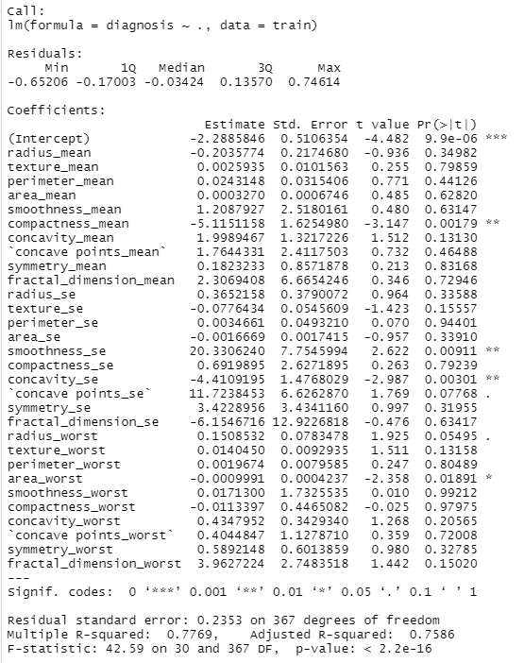

*Figure 1.1: Linear Regression with all variables.*

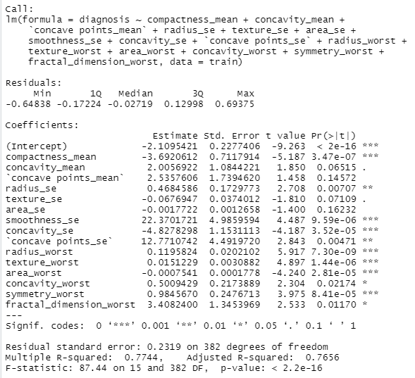

*Figure 1.2: Linear Regression using Stepwise method.*

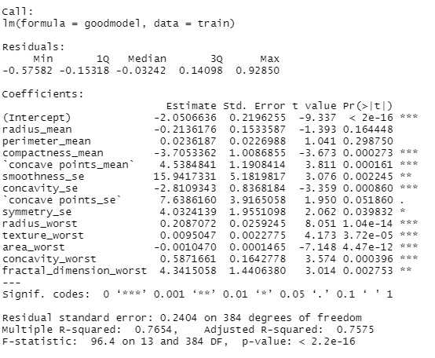

*Figure 1.3: Linear Regression using The Best Model (13 variables).*

Method 2 (Ridge and Lasso Regression)

These will be 2.1, 2.2, 2.3, 2.4 DELETE THIS LINE

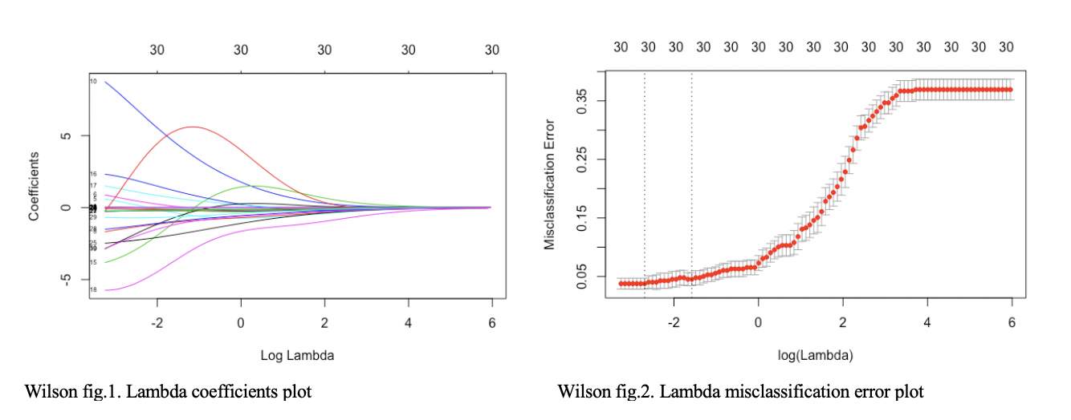

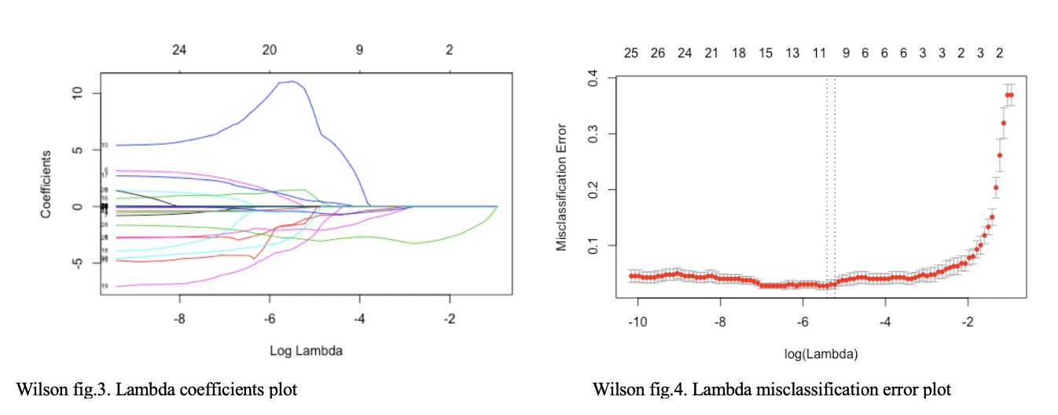

Method 3 (Logistic Regression)

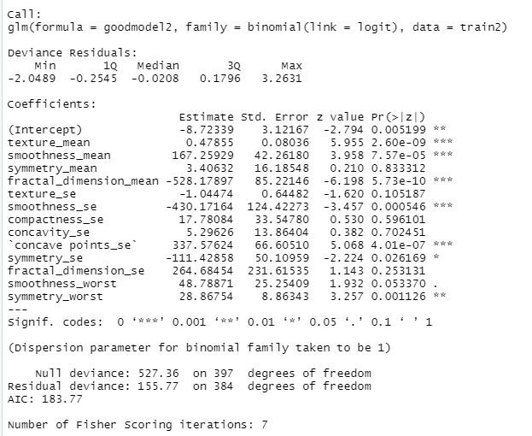

*Figure 3.1: Logistic Regression using The Best Model (13 variables).*

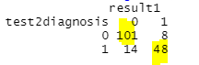

*Figure 3.2: Confusion Matrix using the Logistic Regression.*

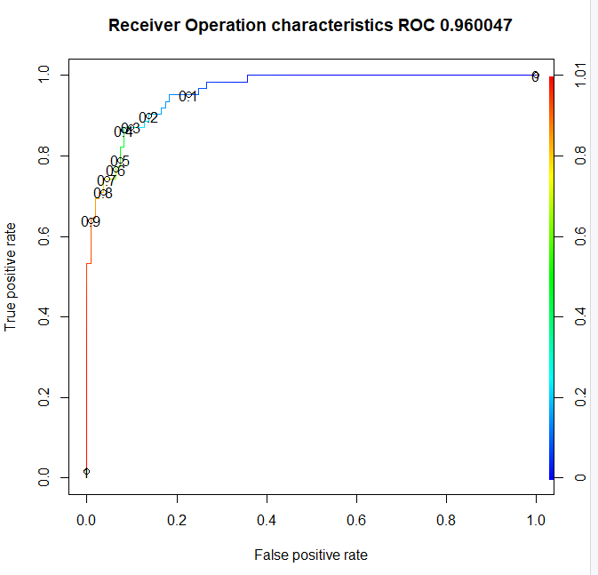

*Figure 3.3: ROC curve using The Best model with Logistic Regression.*

Method 4 (Linear Discriminate Analysis)

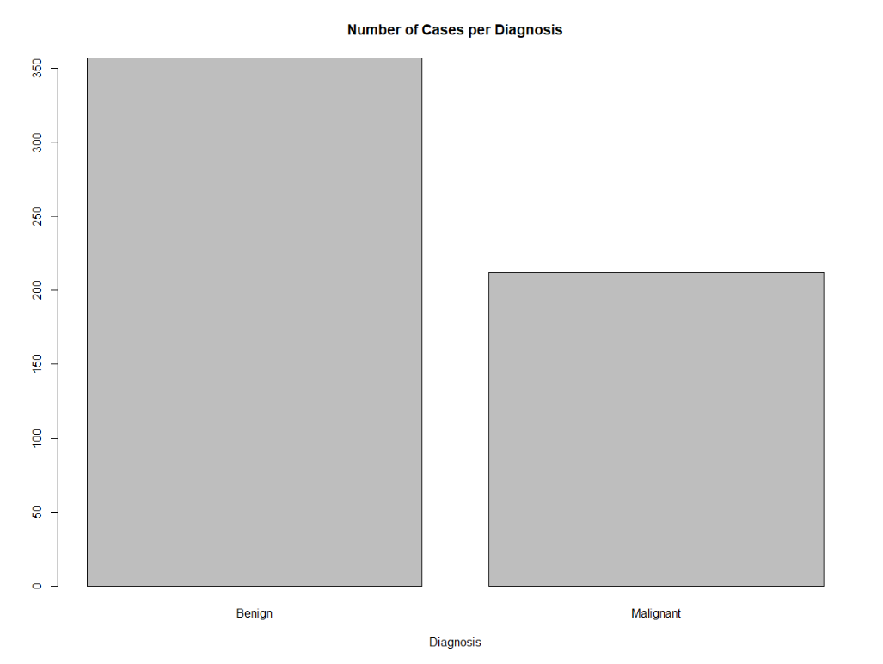

*Figure 4.1: Unbalanced distribution between the response categories*

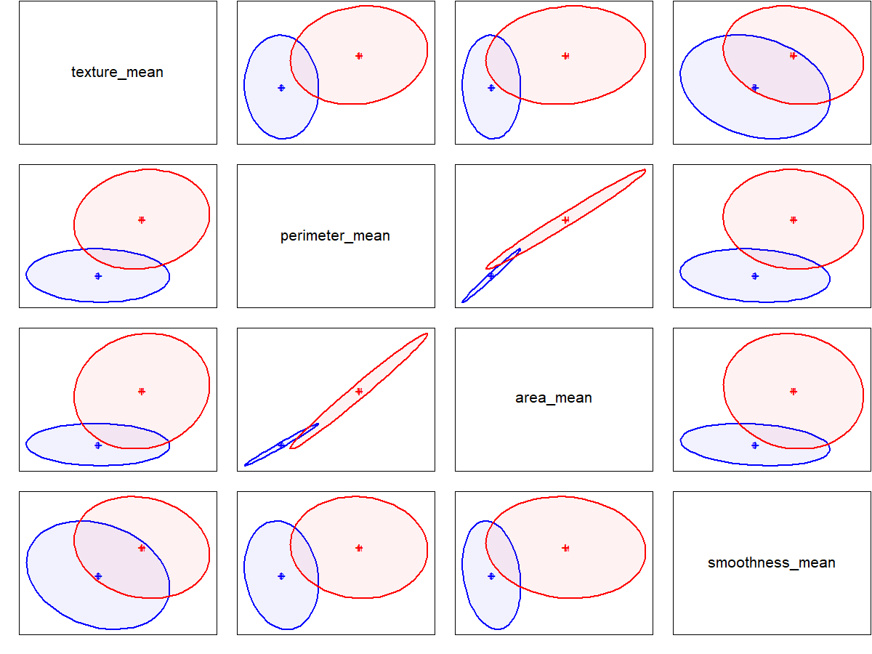

*Figure 4.2: Pairwise variance for Texture, Perimeter, Area and Smoothness*

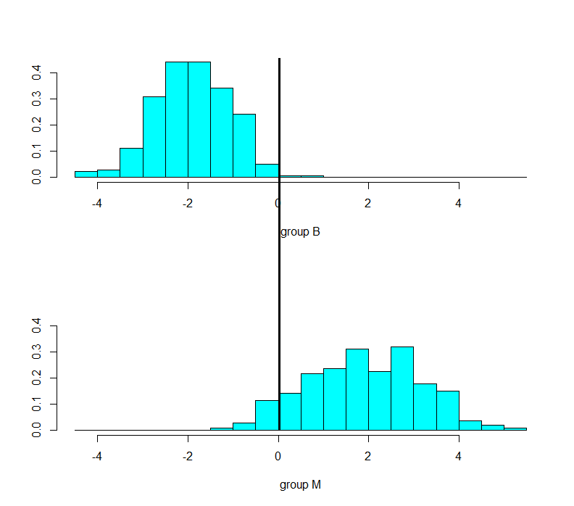

*Figure 4.3: Plot of the first Linear Discriminant (Group B: Benign cases and Group M: Malignant cases)*

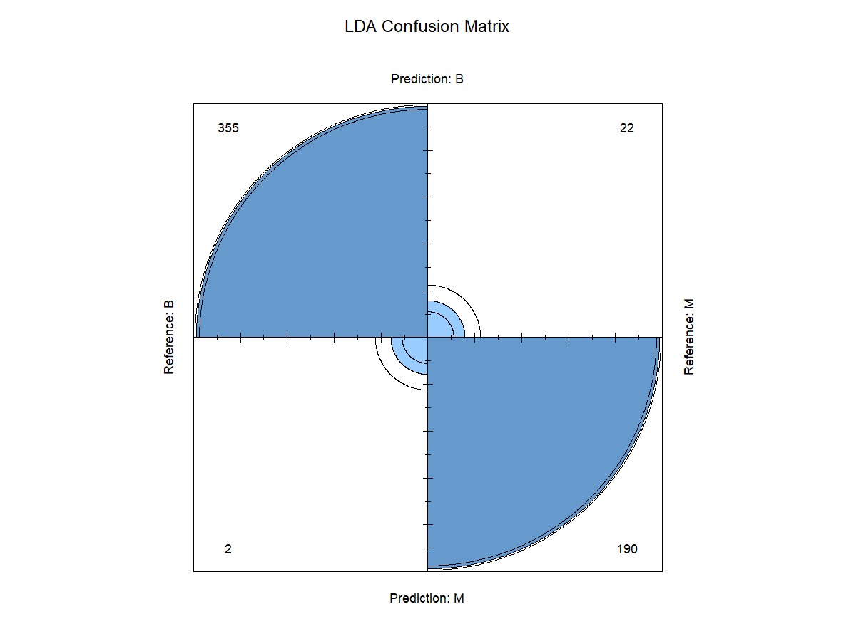

*Figure 4.4: Mis-classification matrix using k-cross validation with Linear Discriminant Analysis*

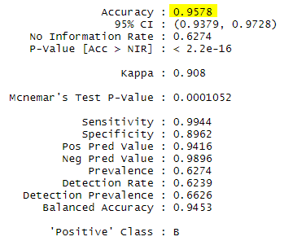

*Figure 4.5: Measures of Performance for k-cross validation with Linear Discriminant Analysis*

Method 5 (Principle Component Analysis)

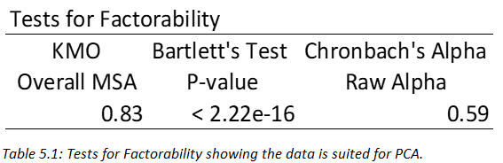

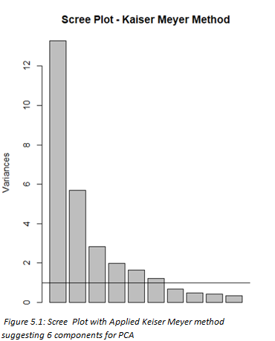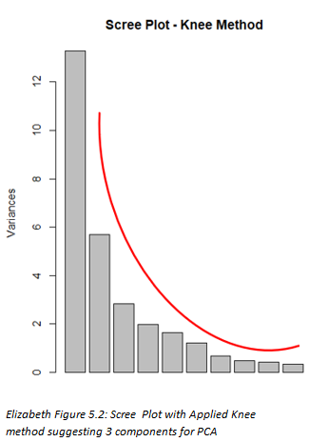

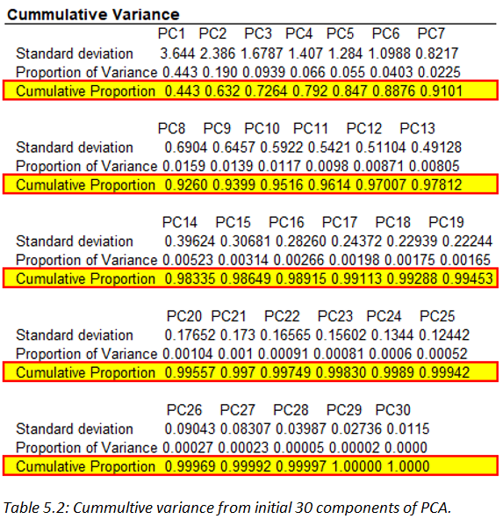

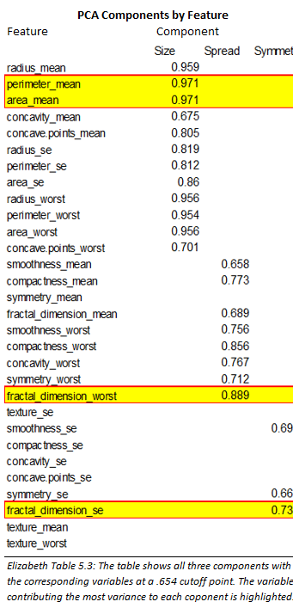 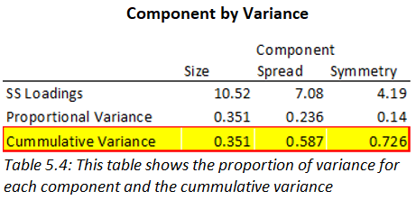

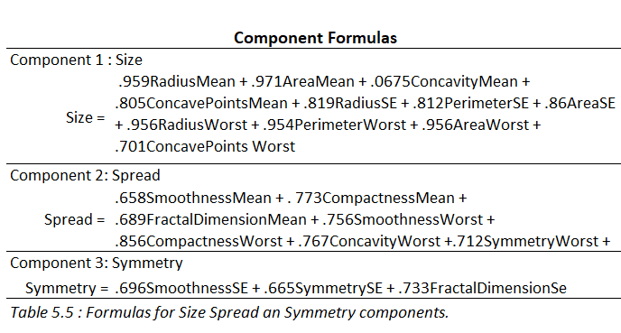

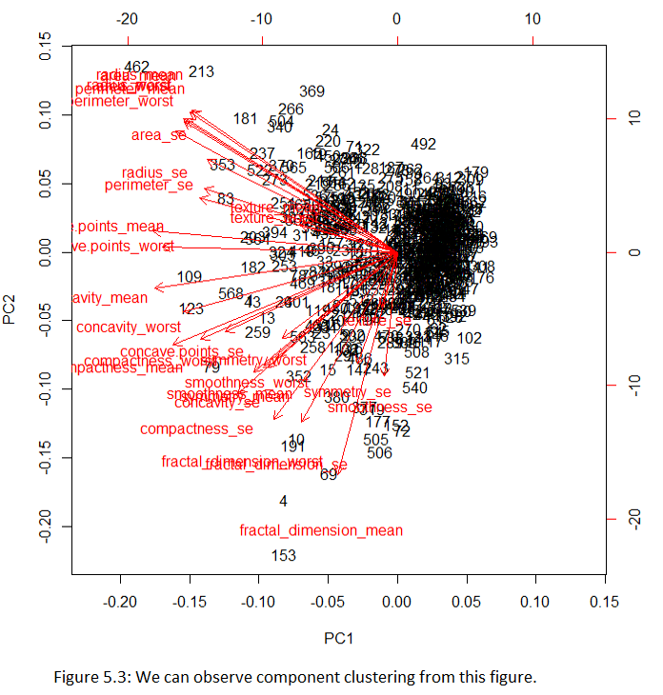

Method 6 (Canonical Correlation Analysis)

|  |  |
| --- | --- |
| **Standard Measurements** | **Specialized Measurements** |
| Radius | Smoothness |
| Texture | Compactness |
| Perimeter | Concavity |
| Area | Concave Points |
|  | Symmetry |
|  | Fractal Dimension |

Figure 6.1 : These are the two groups based on the CCA analysis showing each variable in their respective group of either Standard or Specialized Measurements.

Figure 6.2

|  |  |  |  |  |  |
| --- | --- | --- | --- | --- | --- |
| **Dimensions** | **Wilks' Lambda** | **F-Value** | **df1** | **df2** | **P-value** |
| 1 | 0.009 | 229.14 | 24 | 1951.328 | 0 |
| 2 | 0.186 | 86.63 | 15 | 1546.315 | 3.11e-192 |
| 3 | 0.77 | 19.62 | 8 | 1122 | 7.07e-28 |
| 4 | 0.96 | 7.73 | 3 | 562 | 5.58e-05 |

Figure 6.3 : This is the result of running a hypothesis test using the Wilks’ Lambda test statistic on all four Canonical dimensions.

|  |  |  |  |  |
| --- | --- | --- | --- | --- |
| **Standardized Canonical Coefficients** | | | | |
| Variable Name | Dimension | | | |
| 1 | 2 | 3 | 4 |
| Radius | 6.45 | **13.31** | 5.92 | -0.7 |
| Texture | -0.02 | 0.08 | 0.08 | **-1.06** |
| Perimeter | -7.85 | **-13.24** | 0.23 | 1.58 |
| Area | 0.54 | 0.41 | **-6.3** | -0.52 |
| Smoothness | 0.1 | -0.1 | 0.17 | **0.98** |
| Compactness | -0.71 | -0.76 | **2.79** | -0.26 |
| Concavity | -0.04 | -0.39 | -1.06 | **-1.48** |
| Concavity Points | -0.46 | 1.19 | **-1.43** | 1.22 |
| Symmetry | 0.05 | -0.06 | 0.003 | **-0.09** |
| Fractal Dimension | 0.3 | -0.47 | **-1.37** | 0.08 |

Figure 6.4 : This table breaks down each individual variable and their respective standardized coefficients based on dimension. Each strongest coefficient is bolded for each variable.

|  |  |
| --- | --- |
| **Dimension Two : Outer Measure** | |
| **Variable Name** | **Coefficient** |
| Radius | 13.31 |
| Perimeter | -13.24 |
| **Dimension Three : Inner Measure** | |
| **Variable Name** | **Coefficient** |
| Area | -6.3 |
| Compactness | 2.79 |
| Concavity Points | -1.43 |
| Fractal Dimension | -1.37 |
| **Dimension Three : Characteristic Measure** | |
| **Variable Name** | **Coefficient** |
| Texture | -1.06 |
| Concavity Points | -1.48 |
| Smoothness | 0.98 |
| Symmetry | -0.09 |

Figure 6.5 : This last table similarly shows variables and coefficients like the last table, however this breaks down each variable into their sorted group that is labeled at the top of each grouping.

## References

Desantis, C. E., Ma, J., Sauer, A. G., Newman, L. A., & Jemal, A. (2017). Breast cancer statistics, 2017, racial disparity in mortality by state. *CA: A Cancer Journal for Clinicians,* *67*(6), 439-448. doi:10.3322/caac.21412

Prat, A., Parker, J. S., Karginova, O., Fan, C., Livasy, C., Herschkowitz, J. I., . . . Perou, C. M. (2010). Phenotypic and molecular characterization of the claudin-low intrinsic subtype of breast cancer. *Breast Cancer Research,* *12*(5). doi:10.1186/bcr2635

Stephen B. Fox, Kevin C. Gatter, Russel D. Leek, Adrian L. Harris, Judith Bliss, Janine L. Mansi, Barry Gusterson, Association of Tumor Angiogenesis With Bone Marrow Micrometastases in Breast Cancer Patients, *JNCI: Journal of the National Cancer Institute*, Volume 89, Issue 14, 16 July 1997, Pages 1044–1049,<https://doi.org/10.1093/jnci/89.14.1044>

McFadden, D. (1973). Conditional logit analysis of qualitative choice behavior. In Frontiers in Econometrics (Edited by P. Zarembka), 105-42. Academic Press, New York.